Registration Cost (Includes Meals)  Early Bird Registration (deadline May 7) $275.00  Adult Registration (after May 7) $295.00  Teen Registration (13-19 years) $50.00  Child Registration (12 years & under) Free  Day Rates: Wednesday (1/2 day) $75.00  Thursday (full day) $150.00  Friday (1/2 day) $75.00  Registration  Type Qty. Total  Adult - Early Bird ($275.00) $  Adult ($295.00) $  Youth ($50.00) $  Child (Free) 0.00  Day Rates: Wednesday $  Thursday $  Friday $  TOTAL ………………………………… (Payment must accompany registration) $  Please make cheques or money orders payable to:  CCCC National Conference 2019  Conference Registrars  Registrar: Barb Patterson: Ph. (905) 765-2197  Registrar: Ena Mitra: emitra@rogers.com  Mail Pymt & Registration Form to: Caledonia Congregational Church 97 Argyle Street N. Caledonia, ON N3W 1B8  Flight Information  If transportation is required from airport, provide:  Name of Airport  Airline  Flight Number  Arrival Date & Time  Departure Date & Time |  |  |  | ACCOMMODATIONS  OPTION A  Redeemer University College  777 Garner Road East, Ancaster, ON L9K 1J4  Townhouse Residences: $189+hst =$213.57/night  - Deadline to book: May 10, 2019  - Each townhouse unit has:  - 4 shared bedrooms (2 single beds/room)  - Two bathrooms  - Kitchen, dining & living rooms  - No double or queen beds available  - Nightly rate to be shared among occupants  - I request to share accommodations with (please specify names):  Rent a room for myself only _______________________  Share a room with ________________________________  Share a townhouse with ___________________________  Rent an entire townhouse as a family or as a group _________________________________________________  I require a townhouse near conference rooms ________  To book accommodations at Redeemer, call:  Barb Patterson: (905) 765-2197  OPTION B  Courtyard by Marriott Hamilton  1224 Upper James St., Hamilton, ON L9C 3B1  Hotel Rooms: $152 + tax/night  - Deadline to book (at the discounted rate): June 4, 2019  - To receive this special room rate, mention you are a member of the Congregational Christian Churches in Canada.  - Do you require a shuttle to/from the hotel? ______  To book accommodations at the Marriott, call:  (905) 383-7772 or 1-800-960-2608 |  |  |  |  |  | Your text here  BEYOND THE CROSSROADS  National Conference  July 3 – 5, 2019  Redeemer University College  Ancaster, Ontario  Congregational Christian Churches in Canada
CONFERENCE SCHEDULE  Wednesday, July 3  8:00 AM Breakfast  9:00 AM Worship  9:30 AM Pastor/Spouse Session 1 Charlene Henry  10:30 AM Coffee Break  10:50 AM Pastor/Spouse Session 2 Charlene Henry  12:00 Noon Lunch  1:00 PM REGISTRATION BEGINS  2:00-5:00 PM Free Time  5:30 PM Dinner  7:00 PM Worship; Session 1 – Karl Vaters  Thursday, July 4  8:00 AM Breakfast  9:00 AM Worship  9:30 AM Concert of Prayer  10:30 AM Coffee Break  10:45 AM Break-Out Session (choice of 3)  12:00 Noon Lunch  1:30 PM Annual General Meeting (AGM)  3:00 PM Coffee Break  3:20 PM Break-Out Session (choice of 3)  4:30 PM Free Time  5:30 PM Dinner  7:00 PM Worship; Session 2 – Karl Vaters  Friday, July 5  8:00 AM Breakfast  9:00 AM Worship; Session 3 – Karl Vaters  10:30 AM Coffee Break  10:50 AM Worship; Session 4 – David Schrader  12:30 PM Closing Dinner & Farewells |  |  | SPEAKERS  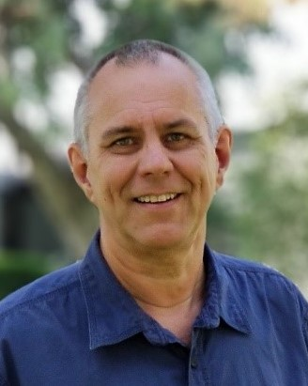  Karl Vaters  Karl is the founder of NewSmallChurch.com, a ministry that encourages, connects and equips innovative small church pastors. Karl’s heart is to help pastors of small churches find the resources to lead well and to capitalize on the unique advantages that come with pastoring a small church. Karl has served in pastoral ministry for over 30 years. He is the teaching pastor of Cornerstone Christian Fellowship in Orange County, California.  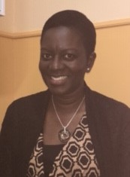  Charlene Henry  Charlene is an ordained minister with the PAOC, serving in ministry for the past 20 years. A Registered Psychotherapist, Charlene worked with Morneau Shepell for 11 years as a Telecounsellor. She has worked as a Chaplain at SylApps Youth Centre, and as Family Ministries Pastor at Queensway Cathedral in Toronto.  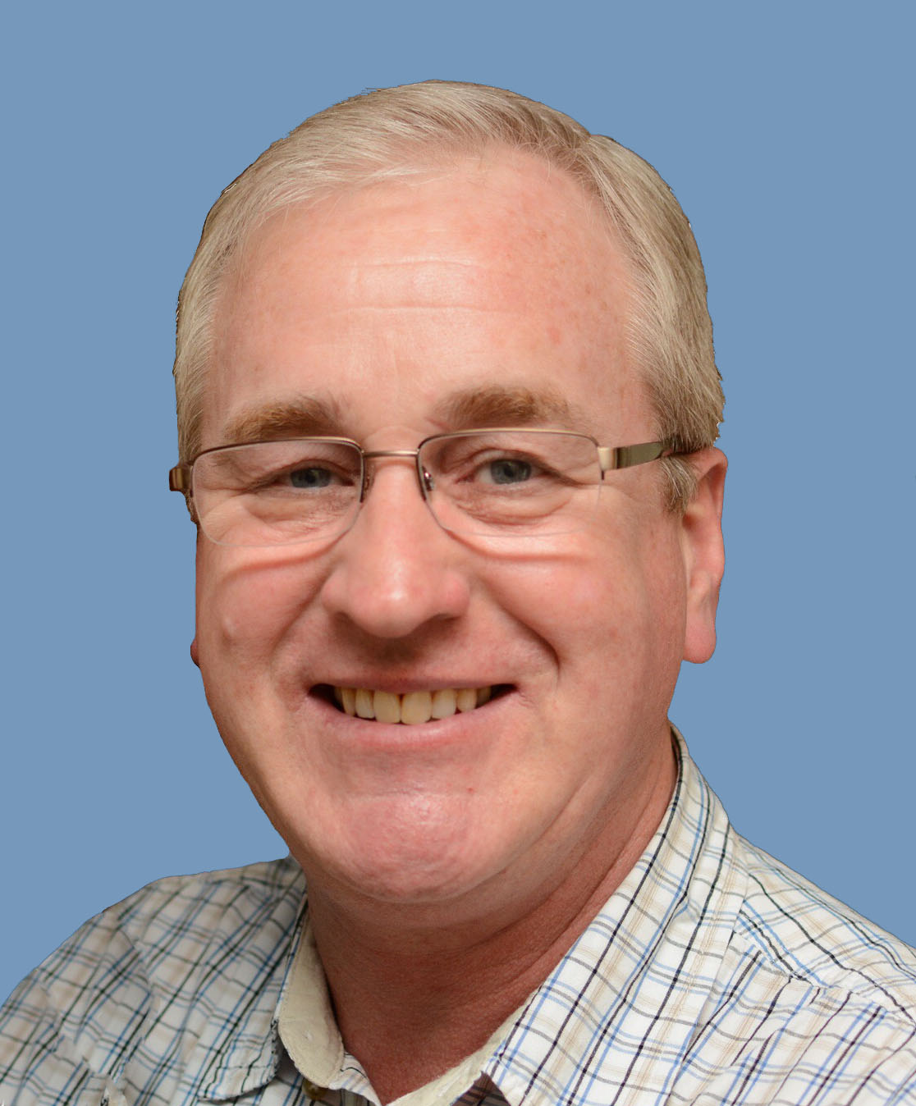  David Schrader  David is the National Pastor of the Congregational Christian Churches in Canada. With a doctoral degree in Church Leadership and Conflict Management, Dave has a wealth of information and skills to assist churches on an organizational and spiritual level. He is pleased to present a message for the closing conference session.  CHILDREN’S PROGRAM  Ages 4 – 12 yrs.  Day and evening sessions for children that include Bible stories, games, crafts, and snacks.  Ages 0 – 3 yrs.  Nursery will be provided during conference sessions. |  |  |  |  |  | REGISTRATION FORM  Adult Registration  Name __________________________________________  Spouse (if attending) _____________________________  Mailing Address_________________________________  City ___________________________________________  Province __________ Postal Code __________________  Phone # ________________________________________  Email __________________________________________  Home Church __________________________________  Please specify any special dietary or accessibility needs: ________________________________________________  ________________________________________________  Please check all that apply:  I am attending as a:  Pastor  Delegate  Spouse   My spouse is attending as a:  Pastor  Delegate  Spouse   I am attending with children (0-12 years)  Name ______________________________ Age _______  Name ______________________________ Age _______  Name ______________________________ Age _______  Accommodations:  I will be staying at:  Redeemer  Marriott  Other   Youth Registration (13-19 years)  Name __________________________________________  Mailing Address ________________________________  City ___________________________________________  Province __________ Postal Code __________________

